Jake Traut

CSCI 4446 Problem Set 8

1. 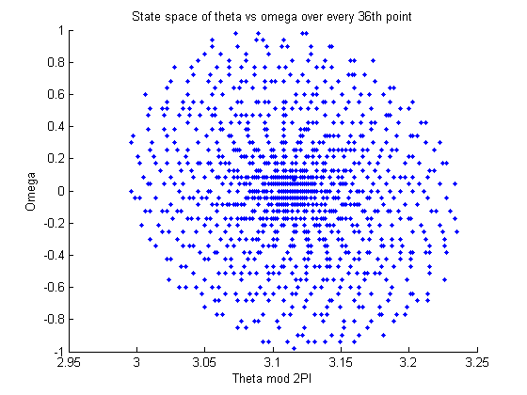State-space trajectory [theta omega] constructed from data set 1 [theta time] using forward divided differences.

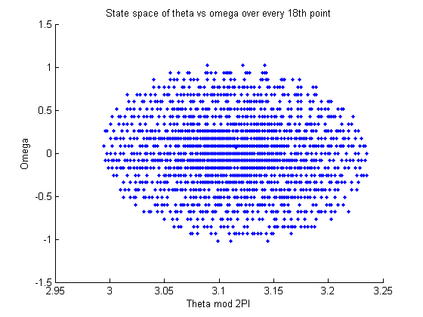These trajectories, down-sampled to every 18th and 36th points of the data set 1, both demonstrate a spiral, but not necessarily the clean spiral one would expect to see with the drive off. This could be due to numerous reasons, like the fact it is using real data that could have its own precision error in capturing the measurements, on top of MATLAB rounding these values to one less decimal precision. The machine arithmetic may also be problematic working with these values, especially when dividing by very small numbers and the potential round-off error. But, overall both these plots is remain well structured, the first more compact and rounded, while the second with an even much greater down-sampling rate demonstrates more of a spiral towards the center. The aim was to use a down-sample rate that isn’t so small that the points are absolutely dependent of each other, while not too high of a rate that would make for complete independence between the points sampled.

1. Delay Coordinate Embedding (reconstruction-space trajectory)

* 1. 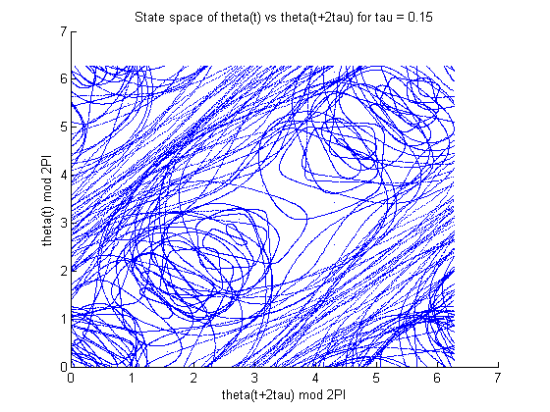The plot for data set 2 shows an example of a chaotic attractor, as the trajectory is completely scattered into a big tangled mess. This demonstrates that we cannot make a clear prediction of where the trajectory will go given a set time interval (tau), as it doesn’t maintain a consistent path in time. Although, there are three stand-out features between the open and elliptical shapes across the center diagonal, and more circular overlays on the top left and bottom right edges, which makes sense for a pendulum that must cross a center and back to get to those points.

SIDE NOTE: The large amount of data was giving me problems in saving the figures (MATLAB would crash) so in order to be able to save a figure and see the features I took only 1/10th of the data.

* 1. 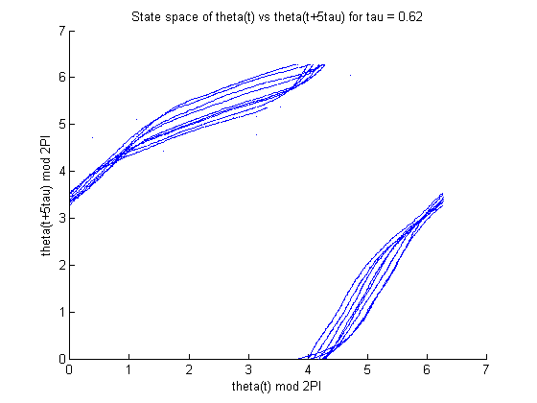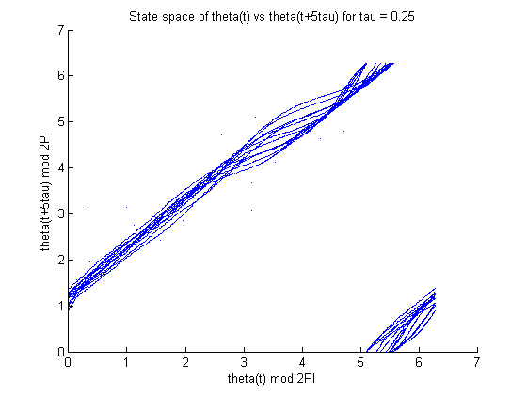Plots for data set 3, and variations of tau values.

It seems as though this chaotic attractor oscillates between two states. As seen before, when tau is small, i.e. 0.01, the reconstruction hugs the main diagonal tightly, but as it grows (tau = 0.25) the attractor unfolds. But, this doesn’t remain the case for this system, as the reconstruction begins to get more compact shortly after (tau > .5). Something interesting going on here is the change between the two plots shown above, which repeats multiple times. At tau = 0.22 we get a plot that’s similar to the one on the right that contain two somewhat more similar parts rather than a main center diagonal, only it is more spread. This is also seen again at tau = 1 but much more tight. When the main diagonal is observed again beyond 1, say tau=1.2, it is even more compact than when first observed at tau=0.01. By tau = 1.41 the diagonal is almost gone as it is one thin line, and after that the plot is left blank as the system continues to return to the same state without capturing anything in between.

1. Takens theorem though experiment
   1. For a driven pendulum we would have box-counting dimension of 3 [time, theta, omega] thus m = 7 was an appropriate dimension, as m > 2*Dbox-count is always sufficient for embedding. As for an undriven pendulum, the box-counting dimension is 2 for [theta, omega] so m = 5 would be sufficient.
   2. If we had used fewer dimensions, m = 2, the trajectory would not be an accurate representation of the system as the actual dimension of a driven pendulum is 3 for time, theta, and omega. Takens theorem states m > 2*dimensions is always sufficient, but m = 25 is overkill that would only amplify the noise.
   3. For a tau as small as 10^-16 you wouldn’t be able to observe changes over time so you would only get a straight diagonal line, whereas using tau = 10^6 could give you completely independent scattered data.
2. 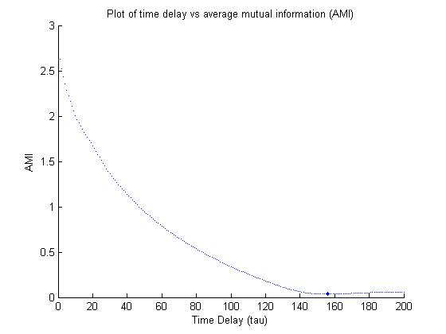 TISEAN command: ./mutual ~/ps8data/data2.first250sec –o ~/mutual_200.txt –D 200

I had my plot increase the size of the point where AMI > prevAMI and output that delay-1 to get the minimum, which is at 155.

Data2 sampled at 0.002s

Thus 155*.002s = .31s

1. 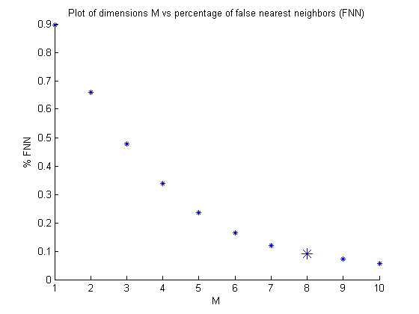TISEAN command: ./false_nearest ~/ps8data/data.first250sec –M 1,10 –d 15 –o ~/fnn.txt

Here I increased the size of the first marker where %FNN < .1, which as you can see is at m = 8.